|  |  |
| --- | --- |
| 2018-10-26  Laurent VALCASARA | INTERNAL |

|  |
| --- |
|  |

# Excel Add-in : Cube Analysis

# Content

This excel add-in allow you to connect directly to a cube, or view the content of a cube (Dimension, measures, Bus Matrix) and permissions.

# Parameters

Once the add-in is installed in excel, you can parameter it by double-click on the label “connected” (or non-connected) at the bottom of the pane

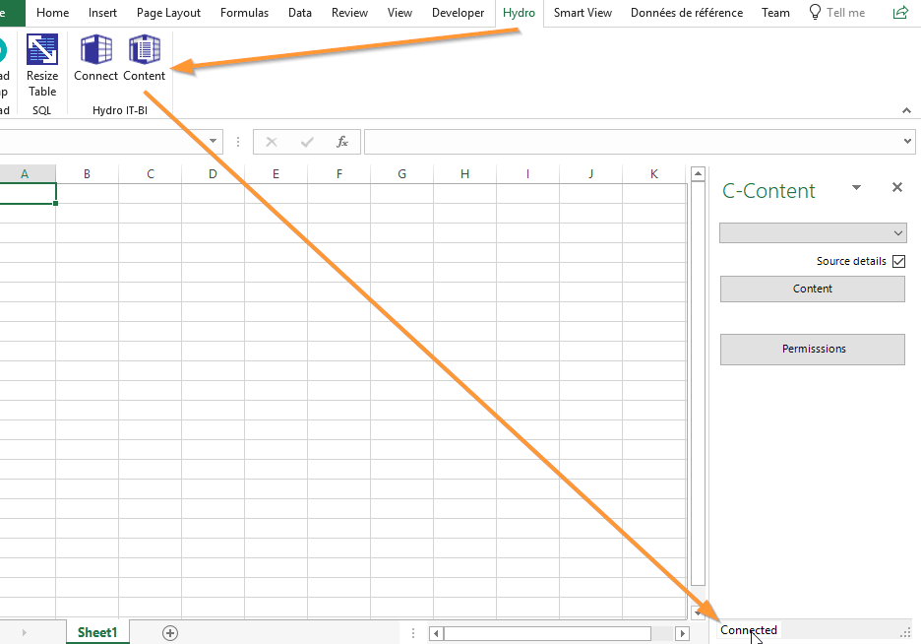

|  |  |
| --- | --- |
| This will open the Parameters Windows :  You can define the string connection to the server which contains your cubes. |  |

# Cube Connect

This button opens a pane on the right side of Excel which contains the list of all cubes existing on the server. Just select the one you want to connect on and click on the “connect” button.

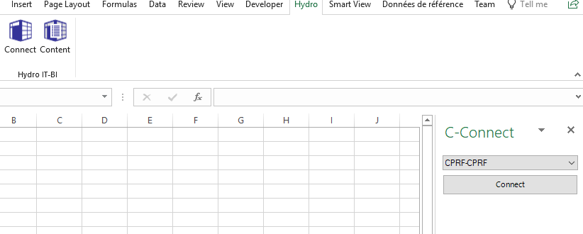

# Cube Content

This button opens a pane where you can select a cube and check its content or permissions:

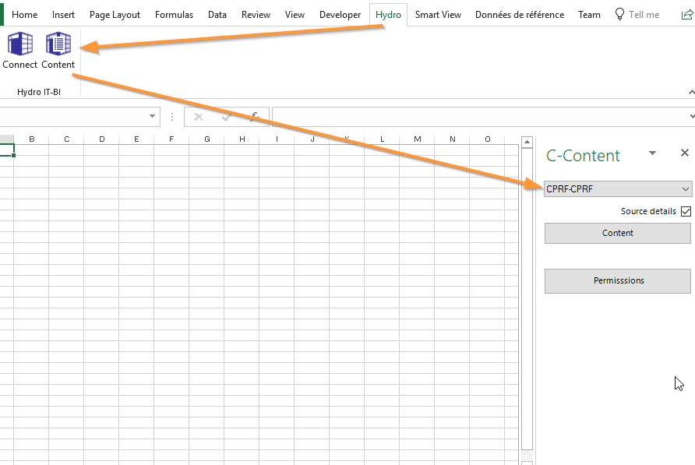

|  |  |
| --- | --- |
| You can chose if you want the “Source details” when extracting the content of the cube. |  |

## Content

This button will extract the “content” of the selected cube :

* dimensions, measuresand calculated Measures in one sheet
* Bus Matrix in another sheet

### Dimensions

(The column “Source” is visible only if “Source details” is checked)

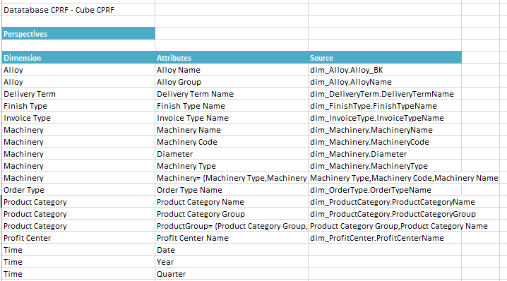

### Measures

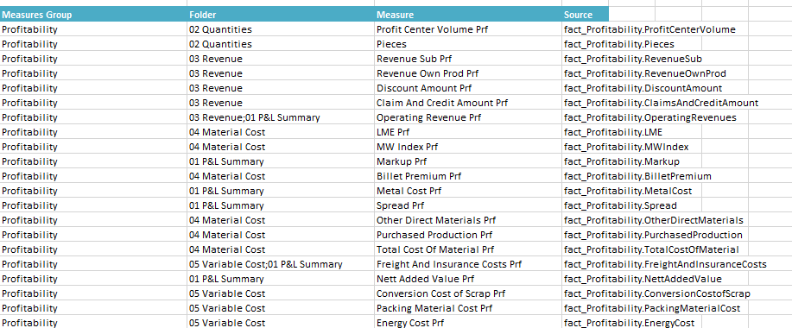

### Calculated Measures

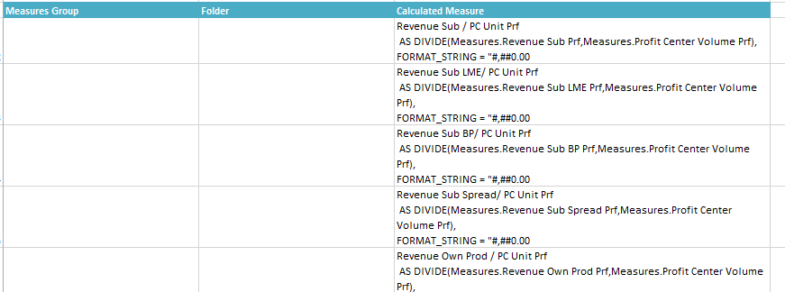

### Bus Matrix

z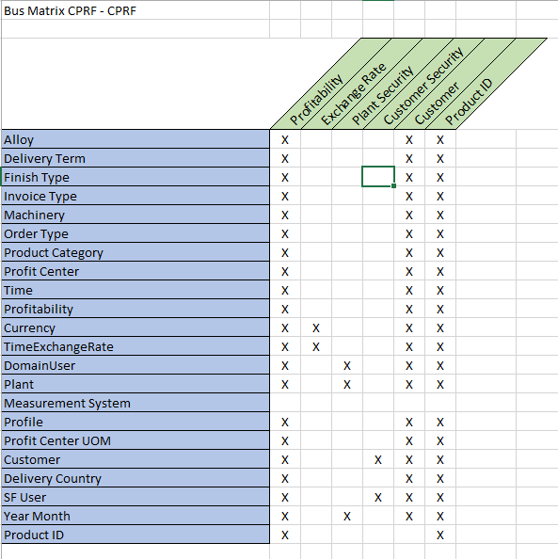

## Permissions

By clicking on this button, you will get the list of all permissions set-up in the selected cube:

